IT PROJECT PHASE 3

Table of Contents
Introduction 1
Information Gathering Methodology (Observation, Participatory, Interviews) 1
Observation 1
Key Findings 1
Participatory Investigation 2
Interviews 2
Analysis of Existing System 3
Student Campus Wi-Fi Network 3
Staff Campus Wi-Fi Network 3
Cellular Data (Mobile Networks) 3
Internet-Based Messaging Platforms (WhatsApp, Email, Instant Messaging) 3
Data Analysis (Data Integrity and Constraints) 4
Data Integrity Measures 4
System & Hardware Constraints 4
Weakness of the Current System 5
Analysis of the Proposed System (Functional Requirements) 7
Non-Functional Requirements 9
Usability 9
Performance 9
Reliability 9
Security and Privacy 10
Compatibility 10
Data Modelling for the Proposed System 10
Server-side entities (Supabase / PostgreSQL) 10
Device-side entities (SQLite, one store per device) 11
Logical entity relationship description 11

Introduction
The Hops application is designed to address critical communication bottlenecks on university campuses caused by heavy Wi-fi network traffic, complex sign-in protocols, and dead zones in wireless coverage. During peak campus hours, high network traffic delays messaging, prevents document access and poses potential safety risks if students cannot communicate during emergencies.
Hops addresses these issues by operating as an offline, proximity-based communication network using Bluetooth Low Energy (BLE) and Bluetooth classic technology. Rather than replacing existing internet platforms, Hops acts as an alternative, infrastructure-independent solution. It enables nearby peer-to-peer messaging, file sharing, emergency alerts, relative proximity estimation via Received Signal Strength Indicator (RSSI), and crowd-density tagging without requiring active Wi-fi or cellular data connections. One qualification applies throughout this document: the peer-to-peer features operate with no network connection at all, but creating an account, signing in and recovering a password contact the Supabase backend and therefore need internet access once. After that first sign-in the application runs offline indefinitely, because the session is held on the device.

Information Gathering Methodology (Observation, Participatory, Interviews)
Three primary techniques were applied to capture detailed operational and user requirements.

Observation
Observations were conducted across high density campus locations such as PC labs, lecture venues and specialized locations like the rooftop student seating area during peak traffic hours. We documented Wi-fi congestion levels, connection dropouts, sign in portal friction and the effect that poor signal coverage had on academic tasks.

Key Findings
Authentication delays: Connecting to student Wi-fi requires Microsoft OAuth single sign-on using student emails. Microsoft OAuth single sign-on (An identity verification process that allows you to log into multiple websites, apps or wi-fi networks using your standard university Microsoft email account and password, without having the create separate accounts for each service.)
Physical Signal Degradation: Outdoor and elevated student spaces specifically the rooftop seating area exhibit extremely weak or non-existent Wi-fi coverage due to distance from access points.

Participatory Investigation
We actively used and tested peer-to-peer scenarios on multiple physical android devices across various campus zones. Findings gathered through hands on participation include:
Wi-fi sign in friction: Experiencing first hand the frustration of repeated Microsoft re-authentication prompts when moving between access points or reconnecting when entering campus.

Interviews
Structured interviews were conducted with key target stakeholders including college students and administrative staff. These interviews identified primary user needs, communication habits during network outages, and requirements for emergency notifications. Key findings proved a demand for lightweight, low-latency offline tool including emergency broadcast capabilities, peer discovery and local crowd-density indicators.

Analysis of Existing System
The existing campus communication ecosystem relies entirely on centralized, internet-dependent infrastructure.

Student Campus Wi-Fi Network
How It Works: Uses a central login system rather than a standard Wi-Fi password. Joining the network blocks your device until a sign-in screen (Captive Portal) opens. While your device saves your Microsoft student email session to auto-connect upon tapping "Sign In," it must still silently verify your credentials with Microsoft's cloud servers in the background.

Staff Campus Wi-Fi Network
How It Works: To protect sensitive administrative systems and files, the campus separates its wireless traffic into distinct student and staff networks. Each network uses a different Wi-fi name (SSID) and operates on an isolated virtual network segment (VLAN) governed by strict firewall rules. This security setup prevents student devices from discovering, accessing or communicating directly with staff devices or with the local Wi-fi.

Cellular Data (Mobile Networks)
How It Works: When campus Wi-fi becomes unavailable or drops connection, mobile devices automatically fail over to commercial cellular networks like 3G, 4G or 5G. This transition routes all internet traffic through nearby cell towers managed by public Mobile Network Operators (MNOs). While this keeps the device connected it bypasses campus infrastructure entirely and relies on personal cellular data plans.

Internet-Based Messaging Platforms (WhatsApp, Email, Instant Messaging)
How It Works: Modern messaging apps use a Client-Server system. If Student A sends a message to Student B sitting right next to them, the message does not hop straight between their phones. Instead, it takes a long detour.

Data Analysis (Data Integrity and Constraints)

Data Integrity Measures
Server-Side Logic Security: Authentication and account operations are implemented via PL/pgSQL database procedures in Supabase (PostgreSQL) rather than client-side logic, preventing unauthorized modification via tampered application binaries.
Relational Integrity: The system keeps two separate stores, and integrity is enforced differently in each. Server-side, the Supabase database holds identity and moderation data across eight tables; every one of them carries a foreign key to the profiles table with cascading delete, so a removed account cannot leave orphaned reports, notifications or audit entries behind. Device-side, the SQLite database holds the feature data in four tables with no foreign keys at all, because a device stores only its own records and so has nothing to join them against. Referential integrity between devices is therefore neither available nor required.
Emergency Alert Authenticity: Alerts can only be dispatched by authenticated, signed-in users with active confirmation prompts to prevent false or automated alert spam.
Data Validation: Multi-part Bluetooth payloads are chunked, validated, and reassembled on receiving devices to preserve message integrity over lossy wireless connections.

System & Hardware Constraints
Bluetooth Range & Environment: Direct peer-to-peer reach is strictly limited to 10–30 meters and is attenuated by walls, metal obstacles, and human body absorption at 2.4 GHz.
Range Extension by Relay: A single transmission reaches only as far as the constraint above allows, so emergency alerts are not limited to one hop. Every device that receives an alert rebroadcasts the identical payload for a short window, which makes any device running the application an unwitting relay. Three such hops carry an alert roughly 60 to 90 metres through a building, reaching people the sender could never have reached directly. Relaying is deliberately applied to alerts only and not to ordinary presence, because relaying a presence signal would make the proximity estimate measure the distance to the relaying device rather than to the person.
Packet Size Limits: Small payload sizes per BLE transmission require large messages and files to be fragmented into smaller chunks prior to broadcast.
Hardware Asymmetry: Lower-specification or older Android handsets support only BLE receiving (scan) functions and cannot transmit advertisements.
Target Scope: The initial implementation targets Android handsets. A Windows desktop build exists and is used for development and demonstration, but the Bluetooth features are Android-only and iOS is out of scope. All peer-to-peer communication is local: no message, file or alert is ever routed over the internet. The backend is contacted only for account registration, sign-in, password recovery and moderation, and is not involved in delivering any message between devices.

Weakness of the Current System
- Student Campus Wi-Fi Network
Authentication Delays & Login Loops: During peak class transitions, heavy concurrent traffic overloads local gateways and authentication servers, causing the sign-in captive portal to loop, time out, or fail to unlock access.
Network Traffic & Bandwidth Throttling: Bandwidth is divided among thousands of active devices, triggering speed limits that severely delay opening shared files or sending messages.
Coverage Dead Zones: Physical distance from access points and structural barriers in outdoor, elevated (e.g., rooftop seating), or enclosed areas cause signal loss, preventing background sign-in completion.
2. Staff Campus Wi-Fi Network
Network Isolation: Student and staff devices operate on completely isolated network layers (separate SSIDs/VLANs) governed by firewall rules, blocking direct device-to-device visibility.
Local Transfer Barriers: Because local interaction is blocked, even adjacent users (e.g., a lecturer and student in the same room) cannot share files directly over Wi-Fi, forcing data through external internet servers.
3. Cellular Data (Mobile Networks)
Building Structural Blockages: Dense construction materials—such as reinforced concrete in lecture halls and basement labs—block mobile signals, creating complete offline dead zones.
Financial Burden: Falling back to personal mobile data when campus Wi-Fi drops forces students to spend personal funds on routine academic communication and downloads.
4. Internet-Based Messaging Platforms (e.g., WhatsApp, Email)
Unnecessary Internet Dependence: Standard platforms rely entirely on centralized client-server routing, requiring a complete, multi-step internet pipeline to deliver messages regardless of physical proximity.
Single Point of Failure: The entire communication chain breaks if any single component fails, including captive portal crashes, mobile tower congestion, ISP outages, or cloud server downtime.

Analysis of the Proposed System (Functional Requirements)
Hops bypasses campus Wi-fi infrastructure and authentication portals by creating an offline, peer-to-peer ad-hoc network using local device Bluetooth.
The functional requirements below describe the system as analysed, covering both applications built from the single code base: the student application and the administrator application. Requirements are grouped by area and identified individually so that the design and testing phases can refer to them. The thirteen requirements carried forward from the planning phase appear here as FR-1 to FR-3, FR-7, FR-10, FR-13, FR-15, FR-18, FR-20, FR-25 to FR-27; the remainder were identified during this analysis.
Table 1: Functional requirements of the Hops system.
ID | Requirement | Description
A. Account and identity (student application)
FR-1 | User registration | Create an account with a username, email address and password.
FR-2 | Email verification | Confirm the registered address using a one-time code, which expires after 24 hours and locks after five failed attempts.
FR-3 | User sign-in | Sign in with email and password; a session token is stored on the device so later launches do not require a network connection.
FR-4 | Password recovery | Reset a forgotten password using a one-time code sent to the registered address.
FR-5 | Account management | Change the registered email address or password, or delete the account entirely.
FR-6 | Device key generation | Generate a public and private key pair on first sign-in. The private key never leaves the device; the public key is published so other devices can verify this user’s alerts.
B. Peer discovery and presence
FR-7 | Nearby user detection | Detect other devices running Hops within Bluetooth range and show them on a radar display.
FR-8 | Anonymous presence | Broadcast a rotating identifier rather than a username, so a passive scanner cannot track a device across campus over time.
FR-9 | Discoverable mode | Optionally broadcast the username in the clear for a short period so a friend standing nearby can tell which contact is which.
FR-10 | Relative distance | Estimate how near another user is from the received signal strength and show it as a relative position on the radar.
FR-11 | Friend requests | Send, accept and decline requests to add another user as a contact.
FR-12 | Contact profiles | Exchange a display picture and short biography with a contact when a connection is established.
C. Messaging and sharing
FR-13 | One-to-one chat | Hold a private conversation with a contact over a direct Bluetooth socket connection.
FR-14 | Mesh message fallback | When a direct connection cannot be established, send the message as a sequence of encrypted Bluetooth broadcasts instead.
FR-15 | Message history | Store sent and received messages on the device and show them when the conversation is reopened.
FR-16 | File and note sharing | Send a photograph, document or short note directly to a nearby device, with a progress indicator on both ends.
FR-17 | Community alerts | Receive and read campus-wide announcements issued by an administrator. Students cannot post to this feed.
D. Safety and emergency
FR-18 | Emergency alert | Allow any signed-in user to raise an emergency alert. The user must confirm and give a short reason before it is sent.
FR-19 | Alert relay | Rebroadcast a received alert so it travels beyond the range of the originating device.
FR-20 | Alert reception | Sound an audible alarm and raise a notification on receipt, even when the application is in the background.
FR-21 | Alert stand-down | Allow the sender to cancel an alert, and expire alerts automatically if no cancellation arrives.
FR-22 | Alert authenticity | Sign each alert with the sender’s private key so a receiving device can verify who sent it without any network connection.
FR-23 | Watch Me | Pair with a chosen contact so both devices monitor the distance between them and warn if they separate.
FR-24 | Rapid trigger | Raise an alert from the phone’s quick settings panel or the application shortcut, without unlocking and opening the app.
E. Campus utilities
FR-25 | Crowd-density tagging | Record how busy a named location currently is, using the number of nearby devices the handset can detect.
FR-26 | Crowd-density viewing | View current and historical density reports for locations on campus.
FR-27 | Task tracker | Create, schedule and complete personal tasks with due dates and reminders.
FR-28 | Lost and found | Post an item as lost or found to nearby devices and mark it resolved once returned.
FR-29 | Study partner finder | Advertise a subject being studied and register interest in another user’s study session.
F. Engagement and personalisation
FR-30 | Mini-games | Play the built-in single-player games, which require no network and no second device.
FR-31 | In-app currency | Earn carrots from the games. Repeatable modes deliberately pay nothing, so the balance cannot be inflated without limit.
FR-32 | Cosmetic shop | Spend carrots on themes, avatars and chat appearance. Nothing purchasable affects gameplay, safety or messaging.
FR-33 | Accessibility settings | Adjust font, text size, colour theme and related display options.
G. Moderation (student side)
FR-34 | Content reporting | Report a message, alert or user to the moderation team, with a category and supporting detail.
FR-35 | Outcome notification | Receive a notification when a submitted report has been reviewed and resolved.
H. Administrator application (second entry point, same package)
FR-36 | Administrator sign-in | Sign in against an account holding the administrator role. The application can never create one; administrator accounts are provisioned outside the application.
FR-37 | Dashboard statistics | Show counts of registered users, open reports and recent moderation activity.
FR-38 | User search and detail | Search registered users and view an individual account with its moderation history.
FR-39 | Moderation actions | Warn, suspend, ban, unban or delete a user account.
FR-40 | Report queue | Review open reports, resolve them, and notify the reporting user of the outcome.
FR-41 | Official alerts | Compose and broadcast a signed campus-wide alert, which student devices display as an official announcement.
FR-42 | Action audit log | Record every moderation action against the administrator who performed it, forming a tamper-evident audit trail.

Non-Functional Requirements

Usability
- The system will provide a simple and understandable user interface
- The main functions will be easily accessible to users
- The system will not require advanced technical knowledge to operate

Performance
- The system should respond to user actions within a reasonable time
- Bluetooth communication should operate efficiently when devices are within an appropriate range
- The system should minimise unnecessary resource usage on the users’ device

Reliability
- The system should provide reliable communication when a Bluetooth connection is available
- The system should notify the user when a Bluetooth connection is lost or unavailable
- The system should handle communication failures without causing the system to crash

Security and Privacy
- The system will protect user information from unauthorized access
- The system will accept an emergency alert only from a registered account that is signed in, will require the user to confirm before the alert is sent, and will keep a record of alerts raised
- Communication and stored user information should be protected against unauthorized access

Compatibility
- The initial version of Hops will support compatible android devices
- The device must have Bluetooth functionality available
- The application should function across supported android devices with different hardware specifications

Data Modelling for the Proposed System
The system stores data in two places that are deliberately kept separate. Account and moderation data is held server-side in a PostgreSQL database; everything a feature produces – messages, density reports, tasks and cached contact detail – is held only on the device that produced it. No message, alert or density report is ever written to the server. This is what allows the system to keep working with no connection, and it also means a compromise of the server would expose account records but not a single conversation.

Server-side entities (Supabase / PostgreSQL)
Eight tables, every one of which carries a foreign key to profiles with cascading delete, so removing an account cannot leave an orphaned report, notification or audit record behind. Row Level Security is enabled on all eight with no policies defined, which denies direct access outright; the application reaches them only through stored procedures that run with the database owner’s rights and return only the columns the caller is allowed to see.
Table 2: Server-side entities, keys and attributes.
Entity | Primary key | Foreign keys | Other attributes
profiles | id | None (root entity) | username, email, password_hash, password_salt, hops_token, token_expires_at, public_key, role, email_verified, banned, ban_reason, suspended_until, created_at
content_reports | id | reporter_id, resolved_by → profiles | content_type, content_snapshot, reason, status, created_at
admin_actions_log | id | actor_id, target_id → profiles | action, detail, created_at
user_notifications | id | recipient_id → profiles | type, title, body, read_at, created_at
official_alerts_log | id | admin_id → profiles | message, created_at
admin_requests | id | requester_id, reviewed_by → profiles | status, requested_at, reviewed_at
email_verification_otps | id | profile_id → profiles | code_hash, expires_at, attempts, consumed
password_reset_otps | id | profile_id → profiles | code_hash, expires_at, attempts, consumed

Device-side entities (SQLite, one store per device)
Four tables holding the data each feature produces. They carry no foreign keys between them, and none to the server: a device holds only its own records, so there is nothing local to join them against and no shared key space in which a join would be meaningful. Crowd density is recorded against a place name typed by the user rather than against a location entity, and the density value itself is the count of nearby devices the handset can detect rather than a figure the user chooses.
Table 3: Device-side entities, keys and attributes.
Entity | Primary key | Purpose | Other attributes
messages | id | Chat and mesh message log | message, sender_id, peer_id, is_for_me, needs_relay, delivered, timestamp
vibe_records | id | Crowd-density reports | location (free text), device_count, timestamp
tasks | id | Personal task tracker | title, description, due_date, start_time, end_time, completed, created_at
contact_profiles | username | Cached detail about known contacts | avatar_path, bio, rotating_seed, rfcomm_mac, updated_at

Logical entity relationship description
profiles to content_reports: one to many. A user may submit many reports, and a moderator may resolve many. Both roles are recorded as separate foreign keys on the same report.
profiles to admin_actions_log: one to many. An administrator accumulates many logged actions; each action also records the account it was taken against.
profiles to user_notifications: one to many. A user may receive many notifications of moderation outcomes.
profiles to official_alerts_log: one to many. An administrator may issue many official alerts over time.
profiles to admin_requests: one to many. A user may submit more than one request for administrator access, each reviewed by another administrator.
profiles to email_verification_otps and password_reset_otps: one to many in each case. Codes are issued repeatedly over the life of an account and expire rather than being deleted.
Device-side tables: no relationships. messages, vibe_records, tasks and contact_profiles are independent of one another and of the server schema. A conversation between two devices exists as two separate local records, one on each handset, with no shared identifier linking them.
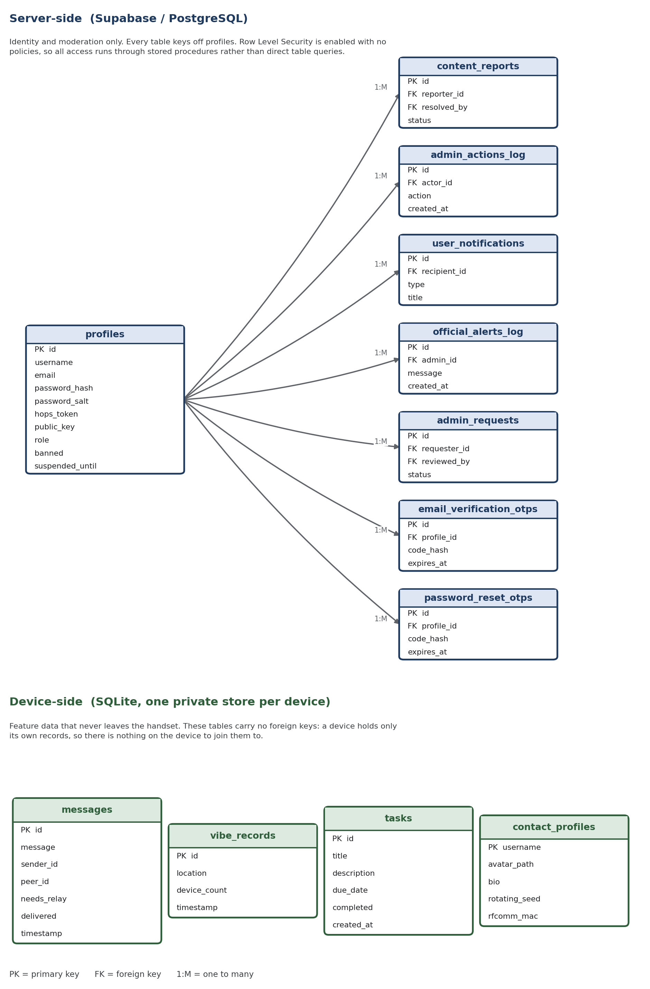
Figure 1: Entity relationship diagram for the Hops system, showing the server-side and device-side stores.

